Project Report

|  |  |
| --- | --- |
| Product Name | Advanced Certificate in Infocomm Technology (Software and Applications) |
| Qualification Name (NICF) | NICF-Advanced Certificate in Infocomm Technology (Software and Applications) |
| Product Name | Front End Web Development |
| Module Name (NICF) | NICF- Front End Web Development(SF) |

|  |  |  |  |
| --- | --- | --- | --- |
| Student name | | Assessor name | |
| Joshua Ho Gwok Hin | |  | |
| Date issued | Completion date | | Submitted on |
| 06/12/2021 | 09/12/2021 | | 09/12/2021 |
|  | |  | |
| Project title | Development of website for a Training Organization | | |

|  |
| --- |
| Learner declaration |
| I certify that the work submitted for this assignment is my own and research sources are fully acknowledged.    Student signature: Date: 09/12/2021 |

Content

1. Project background
2. Project Objectives
3. Task 1: Requirement specification document for website & administration.
4. Task 5: Effectiveness of Lead Generation form and User Interface
5. Task 7: User Guide for the Lead Generation form & its administration

# Project Background

The brick-and-mortal business model has been the mode of operation for ABC Learning Center. The company is looking to benefit from the integration of Web Technologies into the business with a website.  
  
Currently, leads were generated from traditional marketing channels like billboards and flyers. As with many traditional marketing methods, printed content gets outdated easily. Discrepancies in delivered content (especially when multiple versions of flyers are being distributed) can take up a lot of time for clarification with the administrative staffs.

With implementation of the website for ABC Learning Center, the company can have enhancement on several aspects of the operations. Other than establishing an online presence, the company can now share the most updated content to be delivered to users. Users can now get concise and up-to-date information without the limitations of traditional marketing methods.

One of the main objectives of the website is to allow users to register interest for courses. Gathering leads of validated inputs onto a single location is now a walk in the park. Users can go to the registration page (register.html) from anywhere of the website and key in their particulars. The submit button will then activate the validation of inputs entered and will prompt users to double check their input if validation fails.

Only validated data are being fetched and recorded onto the admin.html page. This Registrants page is specifically designed for administrative purposes where data can be added, amend and delete. This automation of data collection and validation makes organizing leads simple.

Project Objective

* Goals
  + Business goals
    - To make the course details available 24/7 on the website → The potential students (leads) are able to access the information anytime, anywhere → there can be more leads → To improve registration rate by 10% within 3 months
    - …
  + User goals
    - To be able to view the details of courses as and when they are able to.
    - To be able to express interest anytime
  + Project Team goals
    - To implement the website for ABC training center using HTML, CSS, JavaScript and JQuery to meet the client requirements, without any bugs.

Requirement Specification

List and document features in a requirements specification document

* 1. Include sections for Website, Lead Generation form and its Administration.

Scope of the project

* Display the content relevant to the courses
* Lead Generation form
* Lead Administration
* Out of Scope:
  + Not integrated with database
  + Responsiveness

Functional requirements

* Common Content
  + Header
  + Footer
  + Navigation
* Home Page
* About Us Page / Profile Page
* Course Listing Page
* Course Details Pages
  + HTML Fundamental Course details page
  + MS Office Course details page
* Course Schedule Pages
  + HTML Fundamental Course schedule page
  + MS Office Course schedule page
* Contact Us Page
* Sitemap Page
* Privacy Policy Page
* Lead Registration/Generation Page
  + Dropdown Selection of the following Options:
    - - Select Course Name –
    - HTML Fundamentals Course
    - MS Office Course
    - I have no idea. I need assistance. Please contact me.
  + Name:
  + Phone:
  + Email
  + Your Comments:
* Lead registration Thank You Page
* Lead Administration
  + Add – to add the new lead
  + View – to view the leads details
  + Edit
  + Delete

Non-functional requirements

(e.g. what do you do to maintain website, test the website, vulnerability check, check for broken links)

* Browsers Supported – Chrome 95, Edge 94, Firefox 93, Safari 15
* User friendliness/user interface/usability – All pages can be accessed within 2 click or less.
* Loading time – 200ms
* Availability – Visit the website on every Monday before 10am or the next working day if it falls on a non-working day.
* Check for broken links using online tools during availability checks.

Technical requirements (software and hardware)

* Software: Platform needed to deploy the application n (tomcat server and its version, java and its version)
  + Development environment: JDK1.8
  + Tomcat 9/ Apache 2.4.51
  + Editor: Visual Studio Code & Dreamweaver 2020
  + Programming languages: JavaScript
* Hardware: client server (windows/mac system)
  + Client (User) – Windows– Windows 11
  + Server (Hosting Environment) – Windows Server

Effectiveness of Lead Generation form

Task Statement:

1. Write a paragraph on the effectiveness of the designed Lead Generation Administration System.

2. Write briefly on effectiveness of the User interface according to 2 metrics

3. Include it as part of Project Report.

**Consider any two measurable benefits because of new LGAM (validations)**

* Increased Productivity by 20 % - Automation in lead to a central location. Minimizing efforts in manual data handling.
* Missing Information – 0% - With the Lead Generation form, there will be validations for each fields so that the users can fill up the form without any mistakes. Therefore, mandatory fields can also be introduced to reduce the missing information to 0%.

**Effectiveness of User Interface (at least 2)**

* Increased user satisfaction rate to 90% - User can find information fast with simple navigation bar. No complicated design.
* Reduce number of page clicks - 10% - Breadcrumbs on several pages helps users have a sense of hierarchy, indirectly reducing the need to find pages with random clicks.
* Task success rate - 50% - Lead generation forms have simple design with less than 5 input fields. Most of which comes with simple instructions should validation fails.

User Guide: Lead Generation Form

Task Statement: Create a User Guide for Lead Generation form and its Associated Administration Module.

Target Audience – Employee of ABC training center

Public Leads

Features

Registration Page - <https://abc-learning-center.sg/register.html>

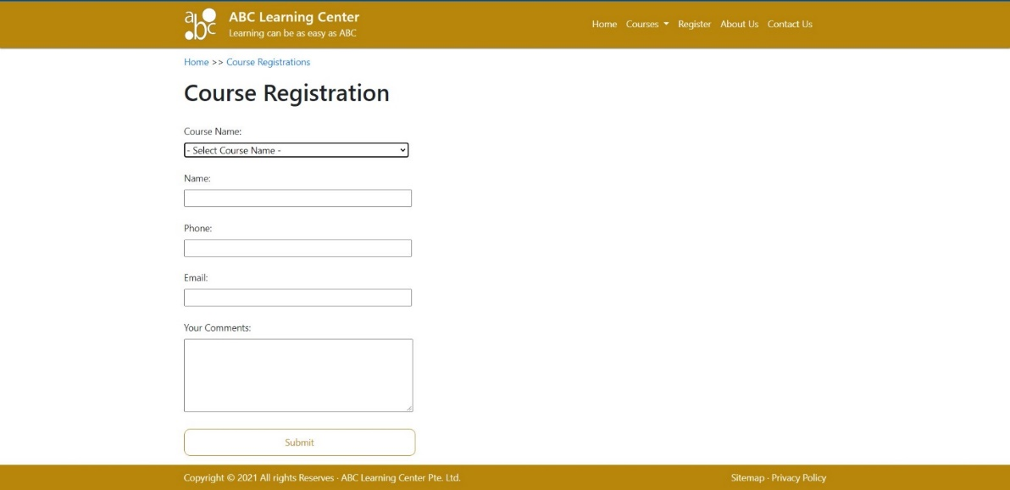

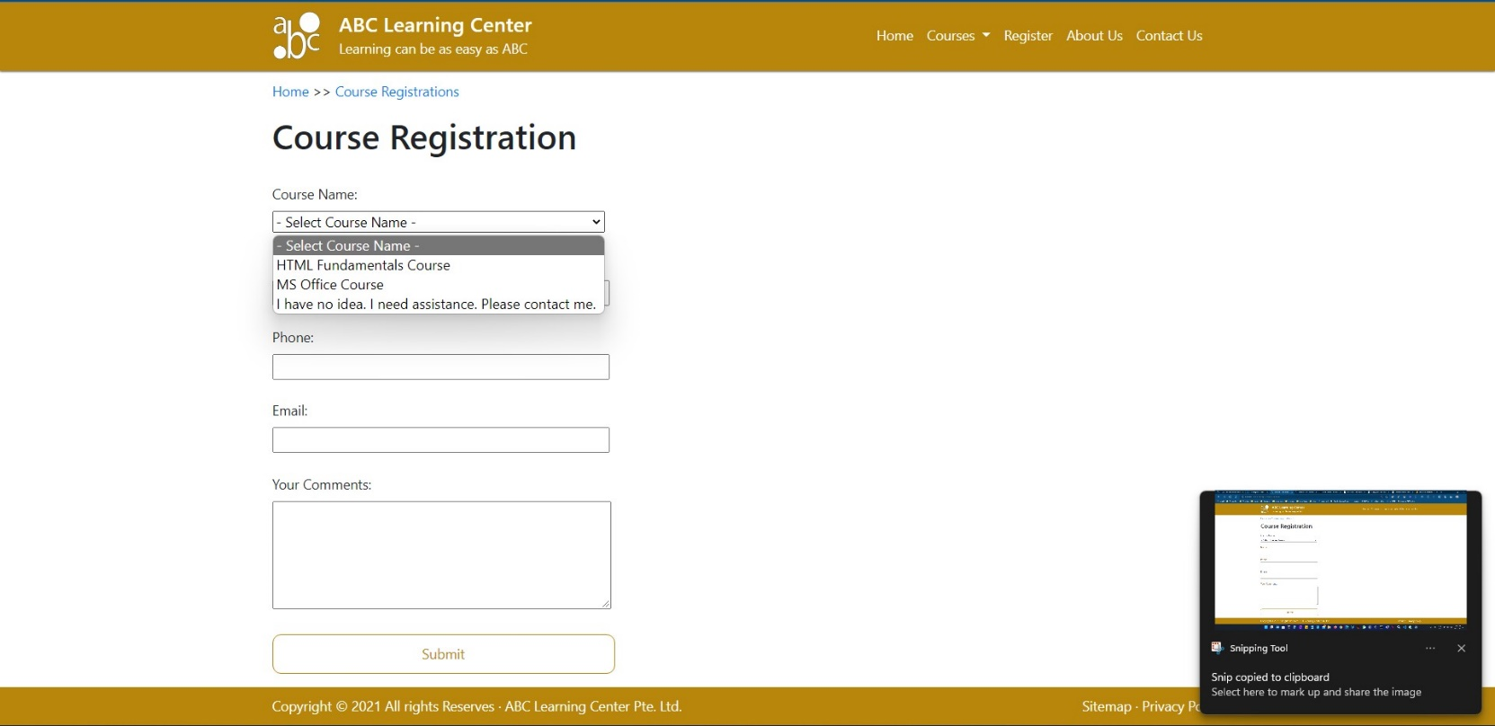

Simple form design with dropdown select options.

1. Select option for Product (courses). This required selection helps administrative/sales team to identify the specific product that interest the sender. This enables a customized follow-up with prospects and enhance closing rate.
2. General information field as required for validation. Prompt/returns error message helps guide users to completing the form. The required fields are Name, Phone & Email.
3. A comment (optional) section is available to users for expressing their concerns/expectations for the next follow-up.
4. Click/Tap Submit button to send contact details to the database/server.
5. Upon successful submission of web form, user will be redirected to

Thank You Page - <https://abc-learning-center.sg/thankyou.html>

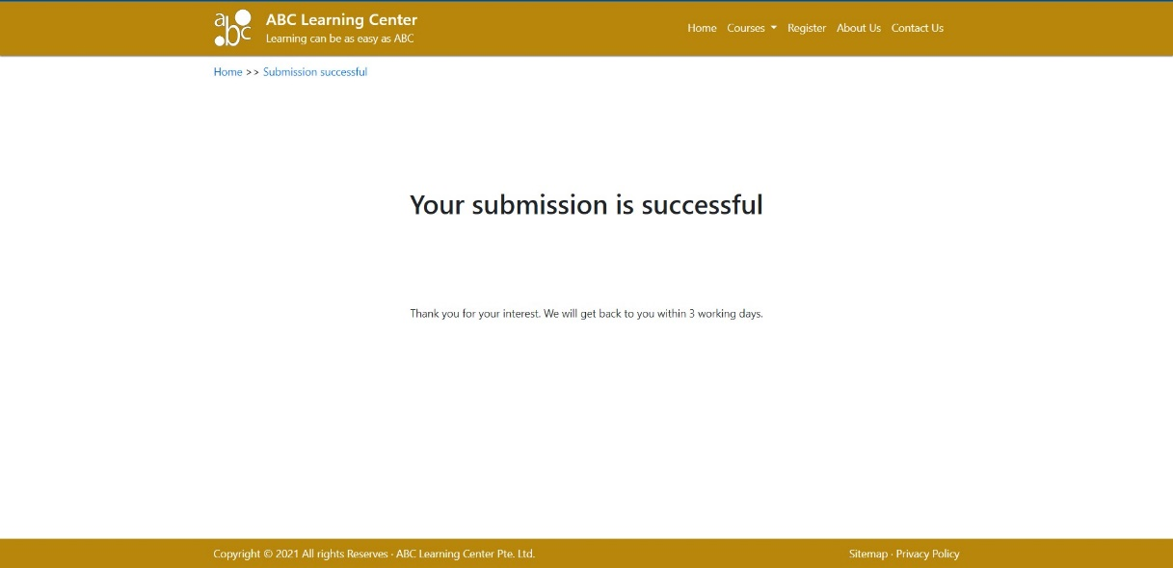

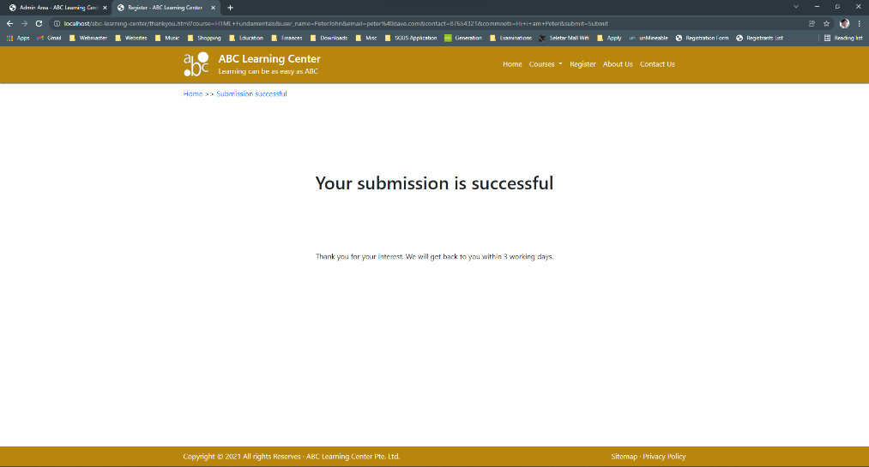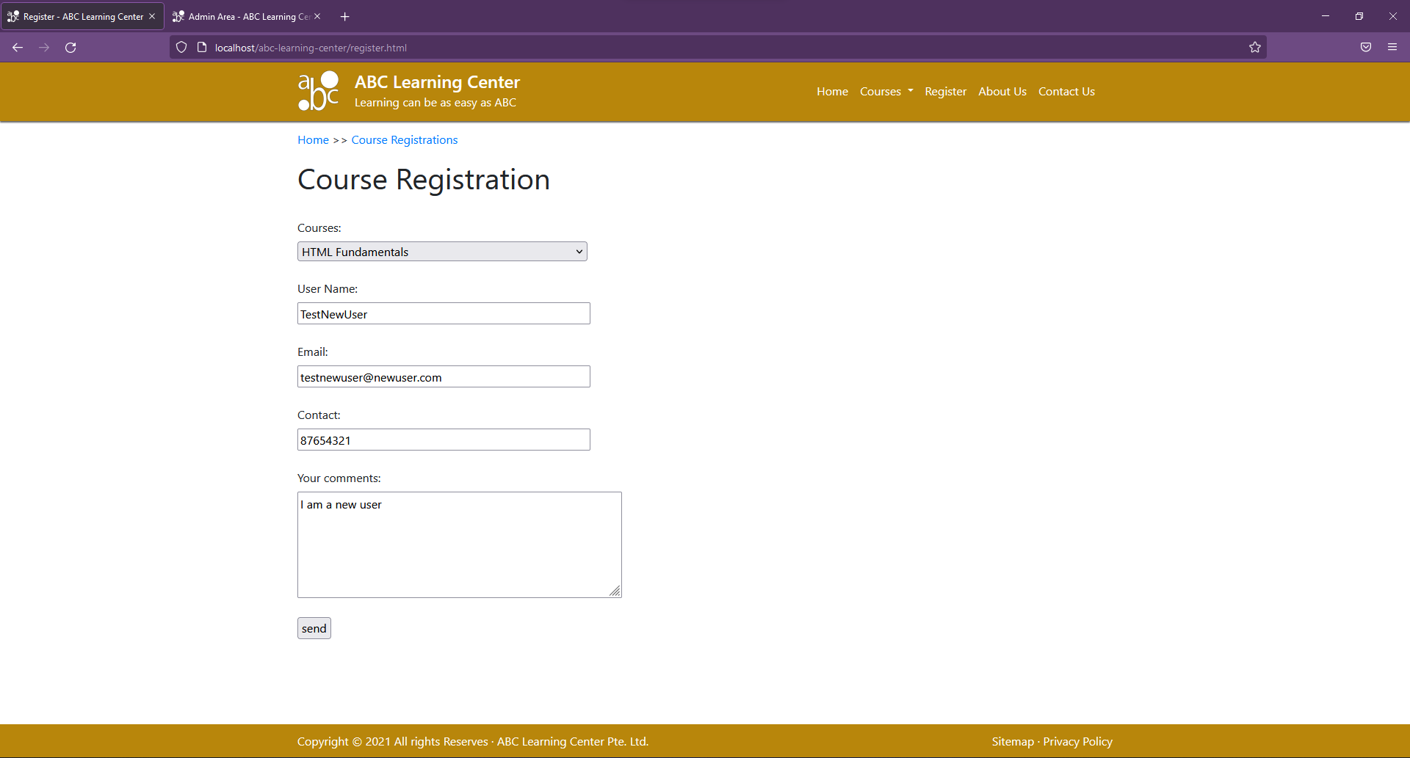

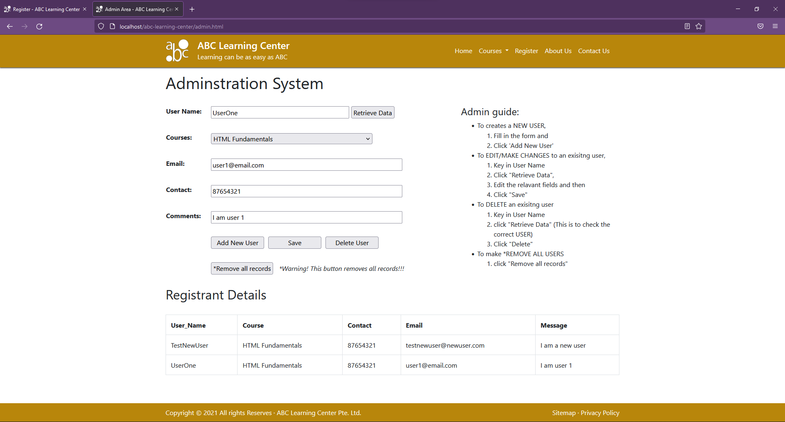

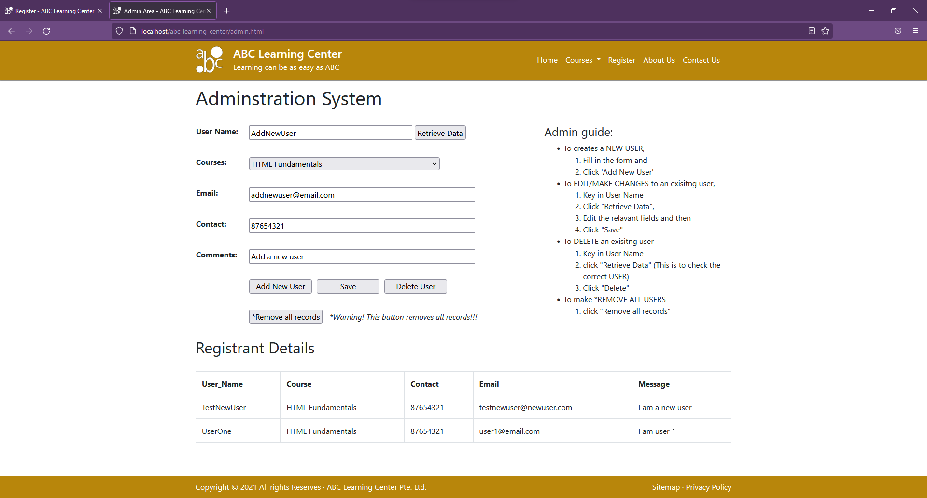

To add new Registrant, Fill in the form and Click 'Add New User'. The add button set new data collected from the input fields to the table above.

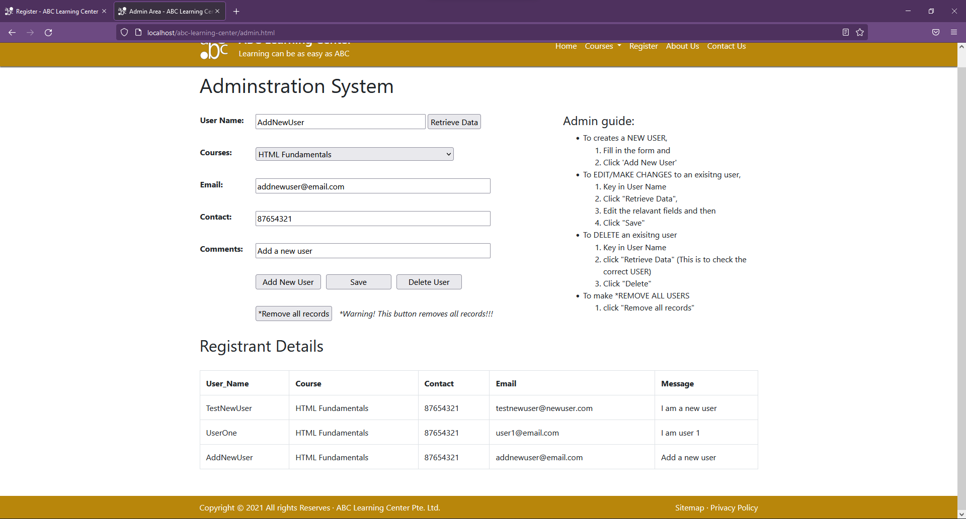

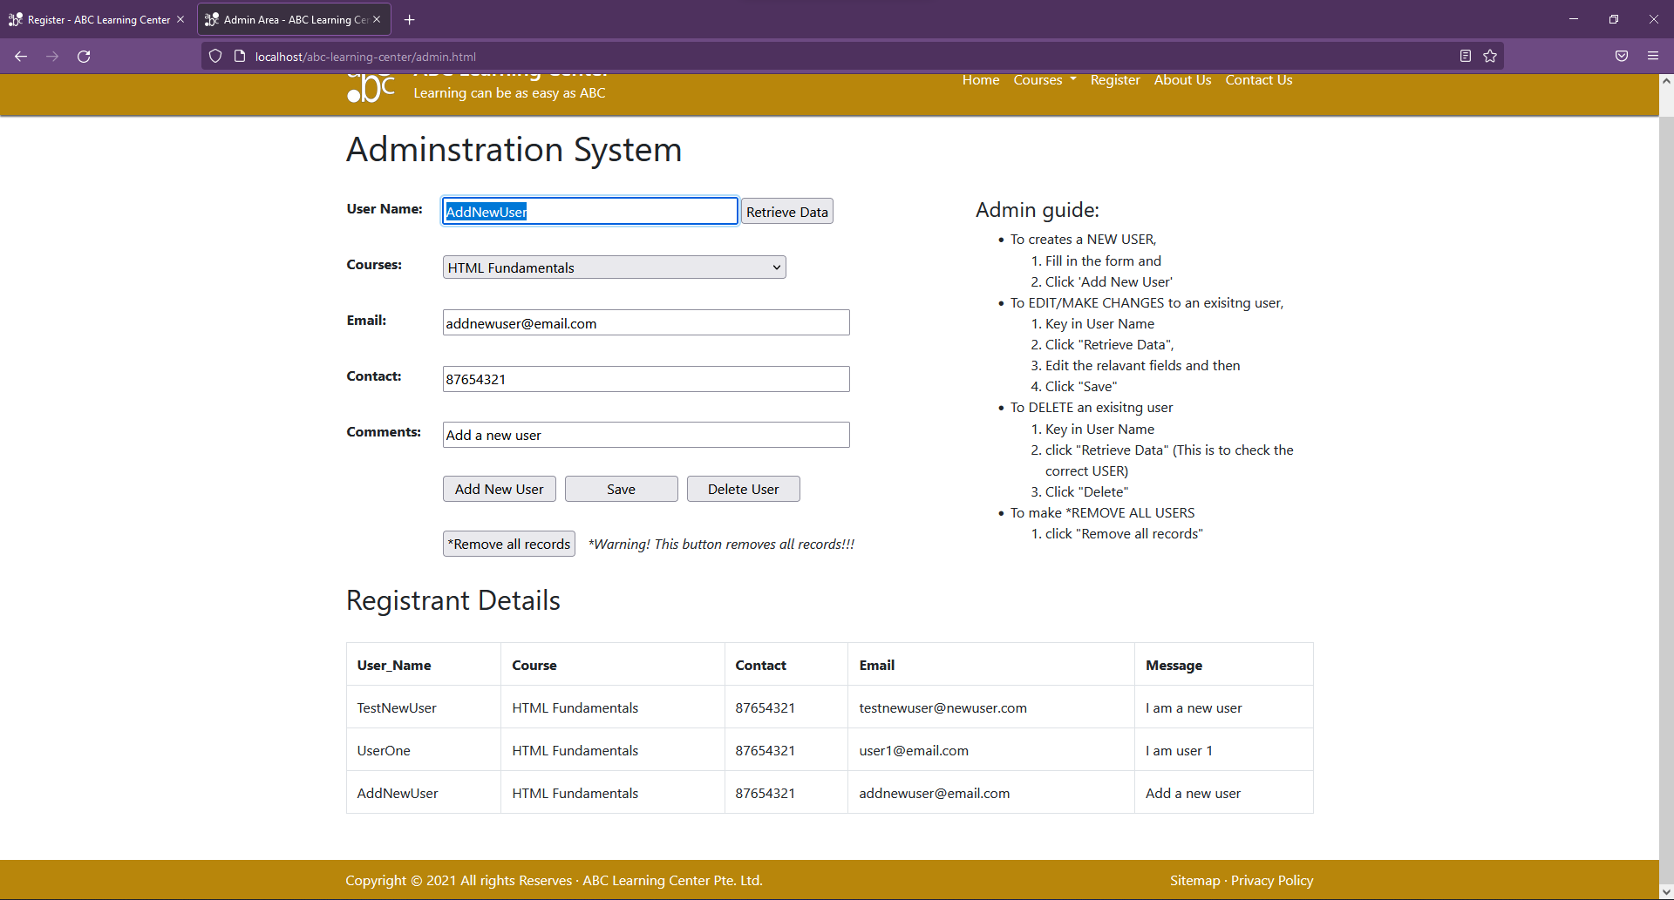

To EDIT/MAKE CHANGES to an exisitng user,

1. Key in User Name
2. Click "Retrieve Data",
3. Edit the relevant fields and then
4. Click "Save"

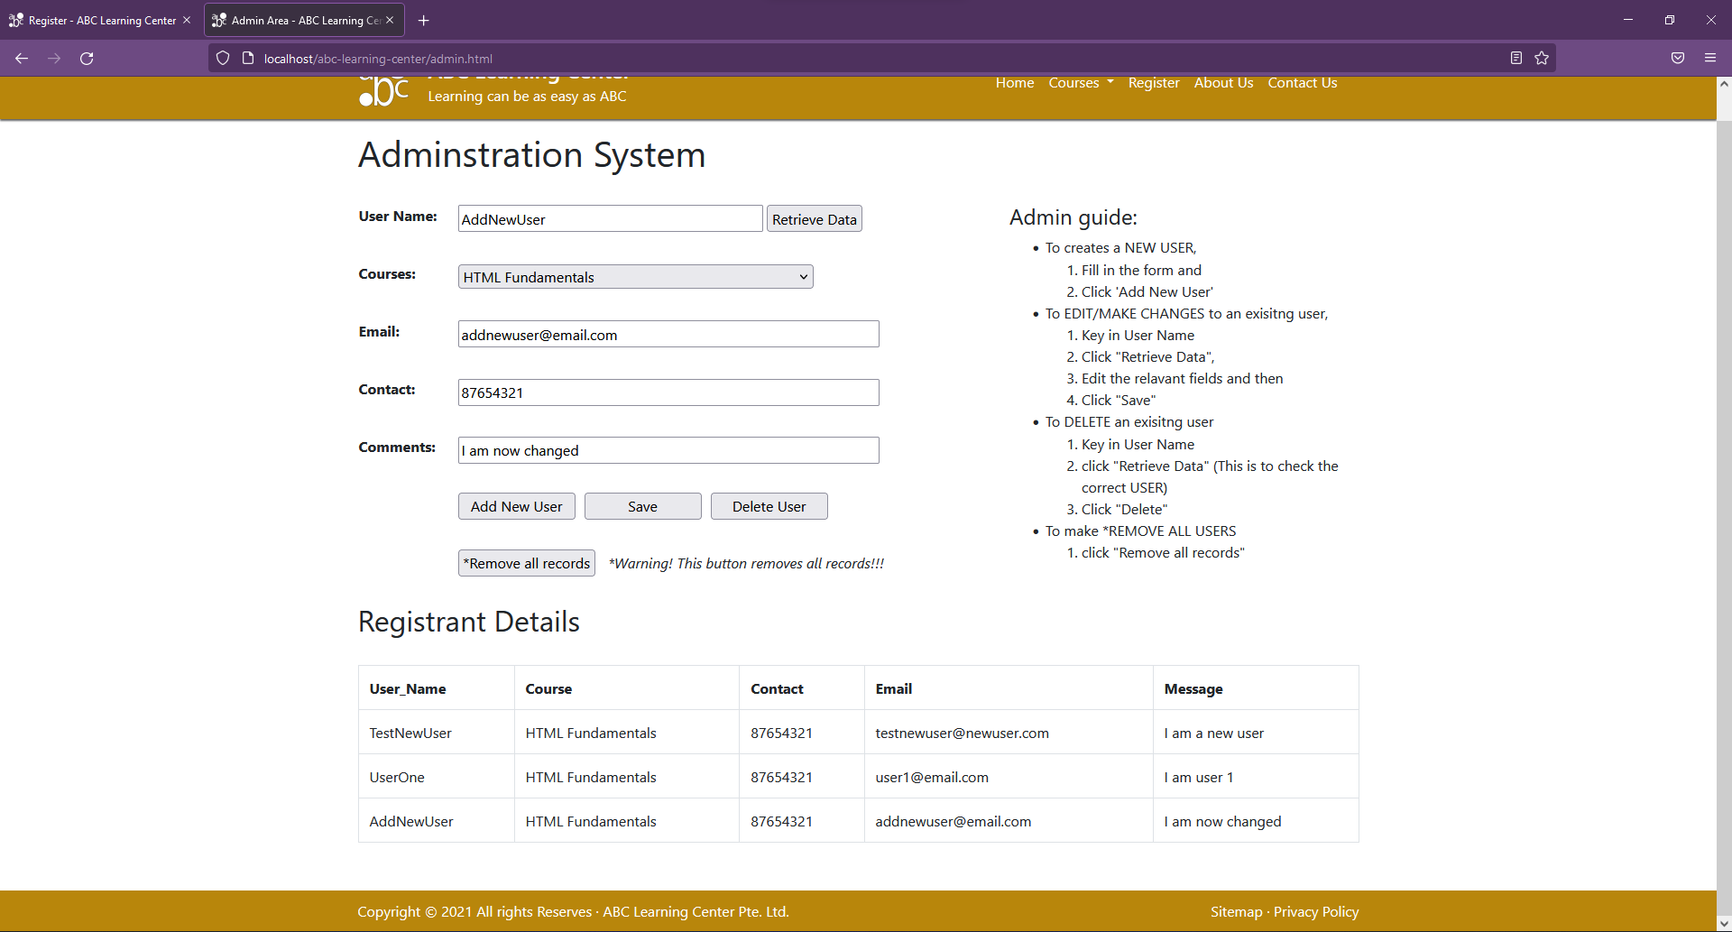

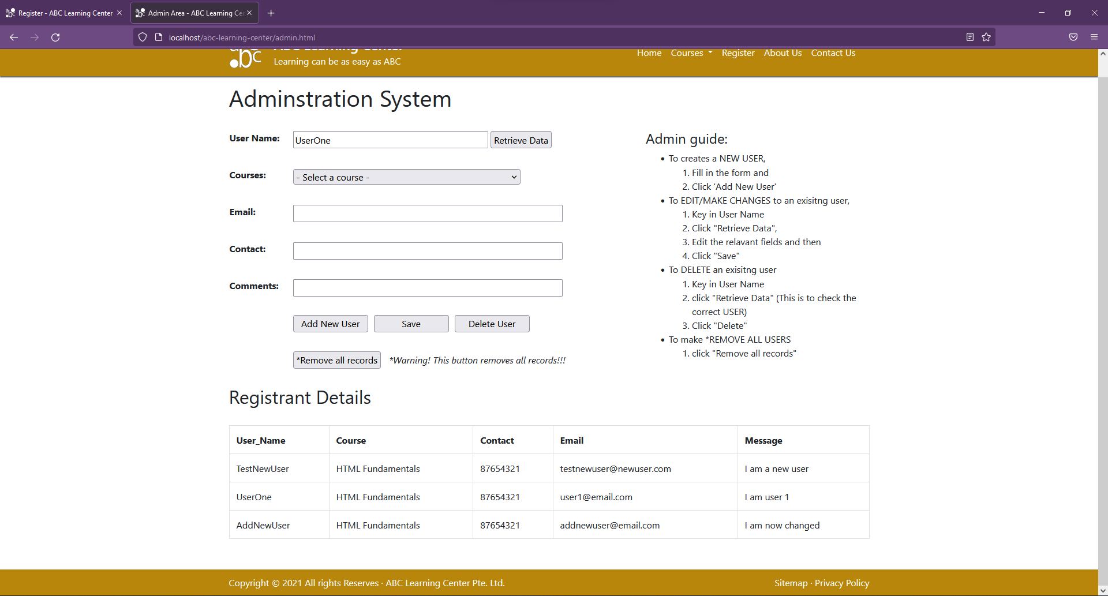

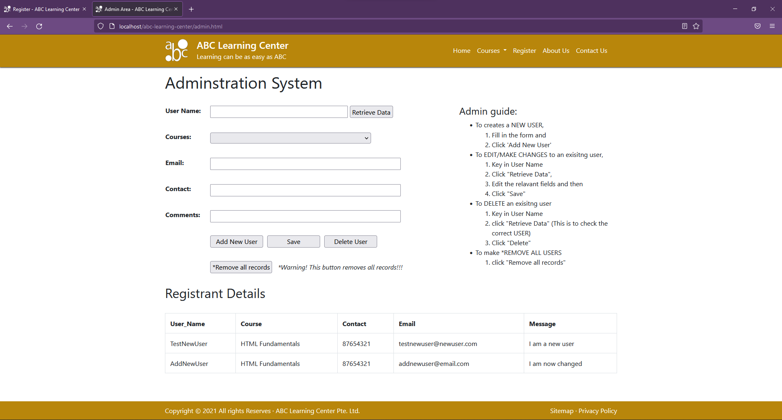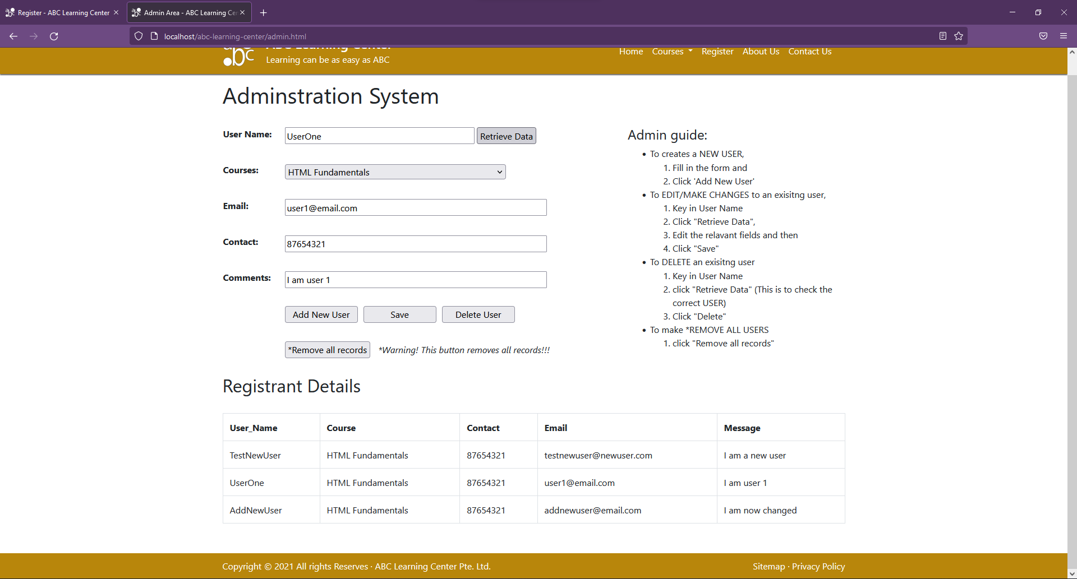

To DELETE an exisitng user

1. Key in User Name
2. click "Retrieve Data" (This is to check the correct USER)
3. Click "Delete"

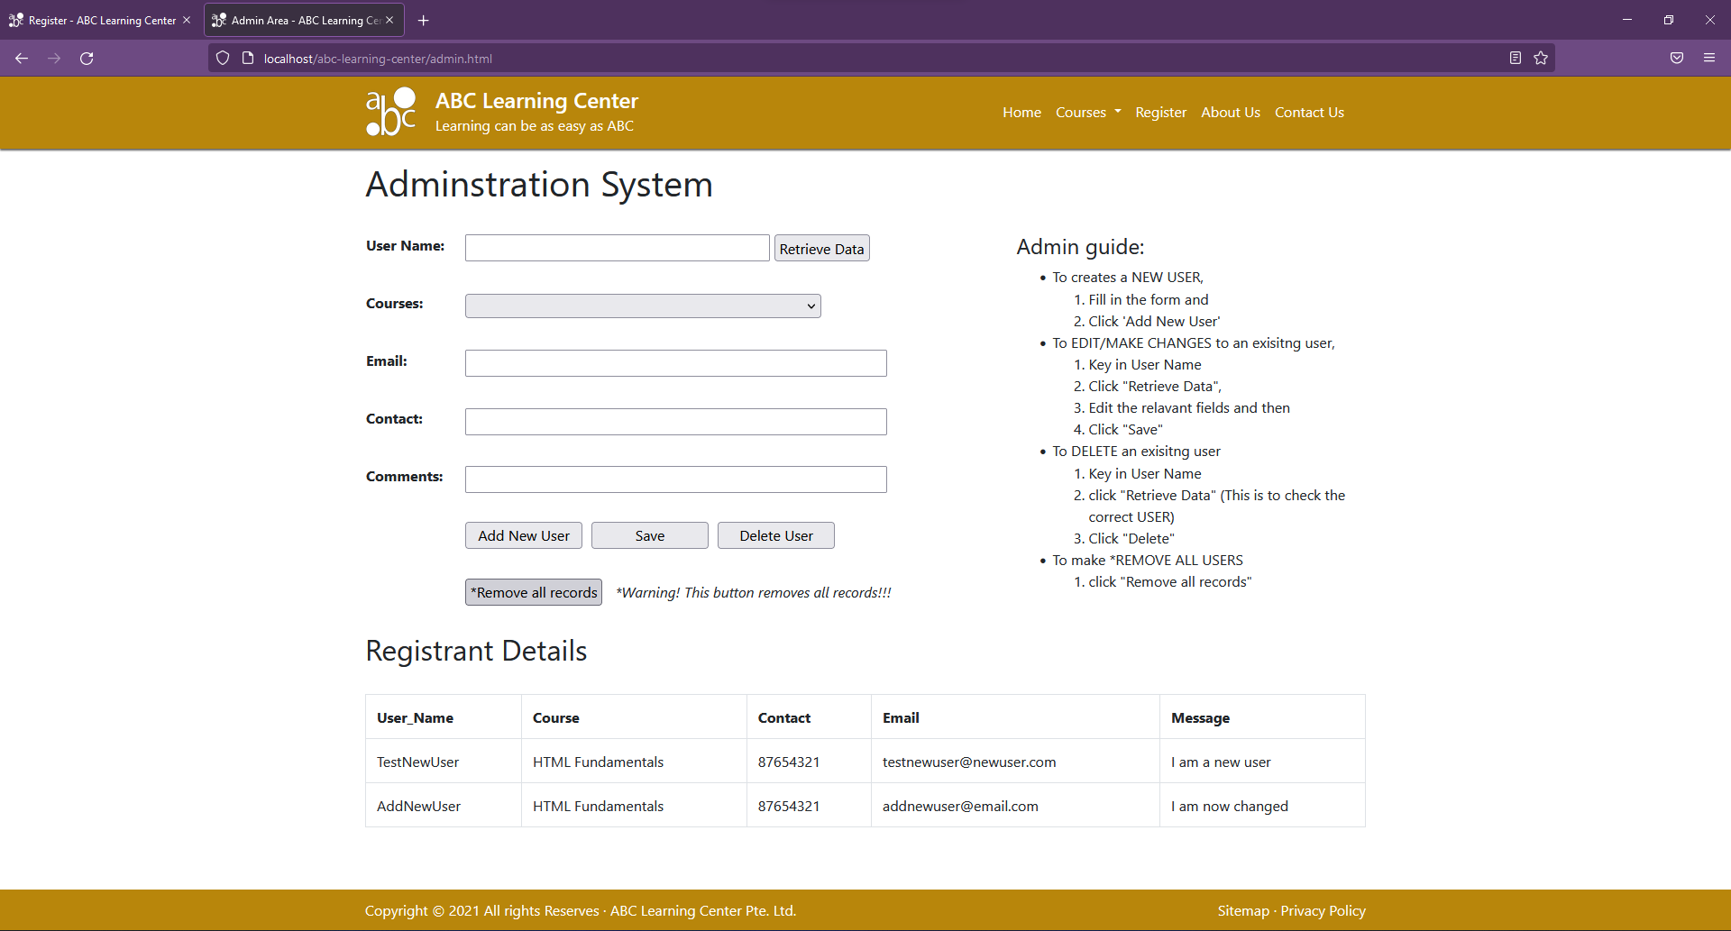

To REMOVE ALL USERS

1. click "Remove all records"

